
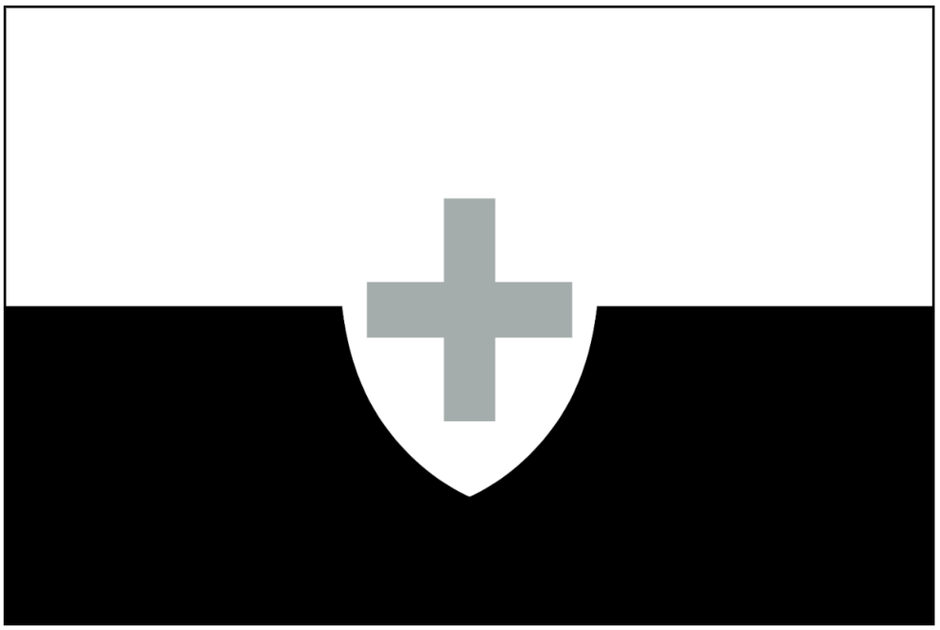

Population - 55 scientists from every nation,
24 Helvetii citizens

Starting Crew, Resources and Units:
2 Untrained Crew
1 Security Unit
1 Science Crew
4 Water
2 Fuel
2 Materials
2 Science
The nation of Helvetii is a young one, the youngest of the New Nations in fact. They were founded after the wars of independence by apolitical refugees that had fled the conflicts. These vagabonds wandered for decades before discovering a previously unknown asteroid cluster with several planetoid-sized bodies and plentiful rare elements, which quickly gained the attention of the other nations. Their constitution swears them to neutrality and they were often called upon to act as an impartial arbiter when international negotiations reached an impasse.
The Baltar is a cutting edge research vessel commissioned, designed, and built for the recently established Helvetii navy. Its focus is on long range observation and scanning, with the intent of finding remote asteroids and other celestial bodies for Helvetii ships to exploit. It also contains general research labs specializing in the physical and material sciences, as befits a nation focused on industrial and economic dominance.
As a new nation without historical adversaries but with a cultural aversion to bloodshed due to their founders' origin as war refugees, Helvetii tries to remain neutral in all international conflicts. Their belief in science and objectivity guides their interactions with the other nations. As such, they do not have any formal foreign policy towards anyone else.
Objectives
• Do not be afraid of speaking out against rash decisions. Your belief in methodical and mindful policy has helped develop your nation from very humble beginnings into an economic and industrial powerhouse.
• Work with the scientists on the Endeavor. They have different ideas than you do, perhaps there is room for cooperation and diversification?
• Your science team is multinational with varying beliefs and viewpoints towards other nations. Don’t feel unduly tied to Helvetii neutrality. Forge your own political path rooted in objectivity, efficiency, and science. Make sure your independent views are heard by your council member and work towards their inclusion in the council.
Diplomat
The Diplomat for the Helvetii can spend the Team Phase (Phase 2) on either of the Helvetii vessels, if they wish. The council role for the Helvetii is currently limited, as they are not a full member of the council. They have been given junior member status and may speak but cannot vote.

